EXPERIMENT 4
Document Storage and Top-k Retrieval using a Vector Database
Name | P Nishanth
Register Number | 192472292
AIM
To store document vectors in a FAISS vector database and retrieve the top-k closest documents for a query.

PROCEDURE
- Import FAISS and NumPy.
- Prepare sample documents and illustrative vector embeddings.
- Create a FAISS index and store the document vectors.
- Set a query vector and the required top-k value.
- Search the FAISS index.
- Display the top-k retrieved documents with their distances.

PROGRAM
# Install first: pip install faiss-cpu numpy import faiss import numpy as np

documents = [
"Python is easy to learn.",
"AI is used in smart machines.",
"SQL manages databases.",
"Machine learning learns from data."
]

# Illustrative document embeddings vectors = np.array([ [1.0, 0.0, 0.0],
[0.0, 1.0, 0.0],
[0.0, 0.0, 1.0],
[0.0, 0.9, 0.1]
], dtype="float32")

index = faiss.IndexFlatL2(3) index.add(vectors)

query_vector = np.array([[0.0, 1.0, 0.0]], dtype="float32") k = 3
distances, indices = index.search(query_vector, k)

print("Top", k, "Retrieved Documents:") for rank, doc_id in enumerate(indices[0], start=1):
print(rank, documents[doc_id],
"Distance:", round(float(distances[0][rank - 1]), 3))

OUTPUT

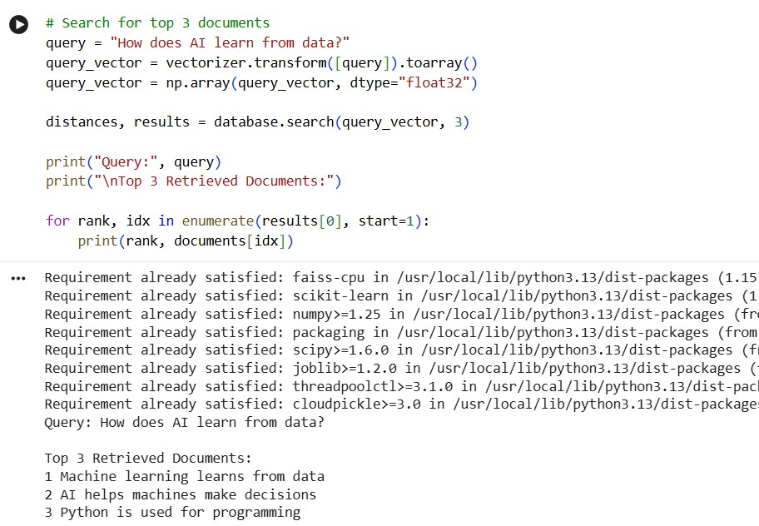

RESULT
Thus, documents were stored in a FAISS vector index and the top-k nearest documents were retrieved successfully.

